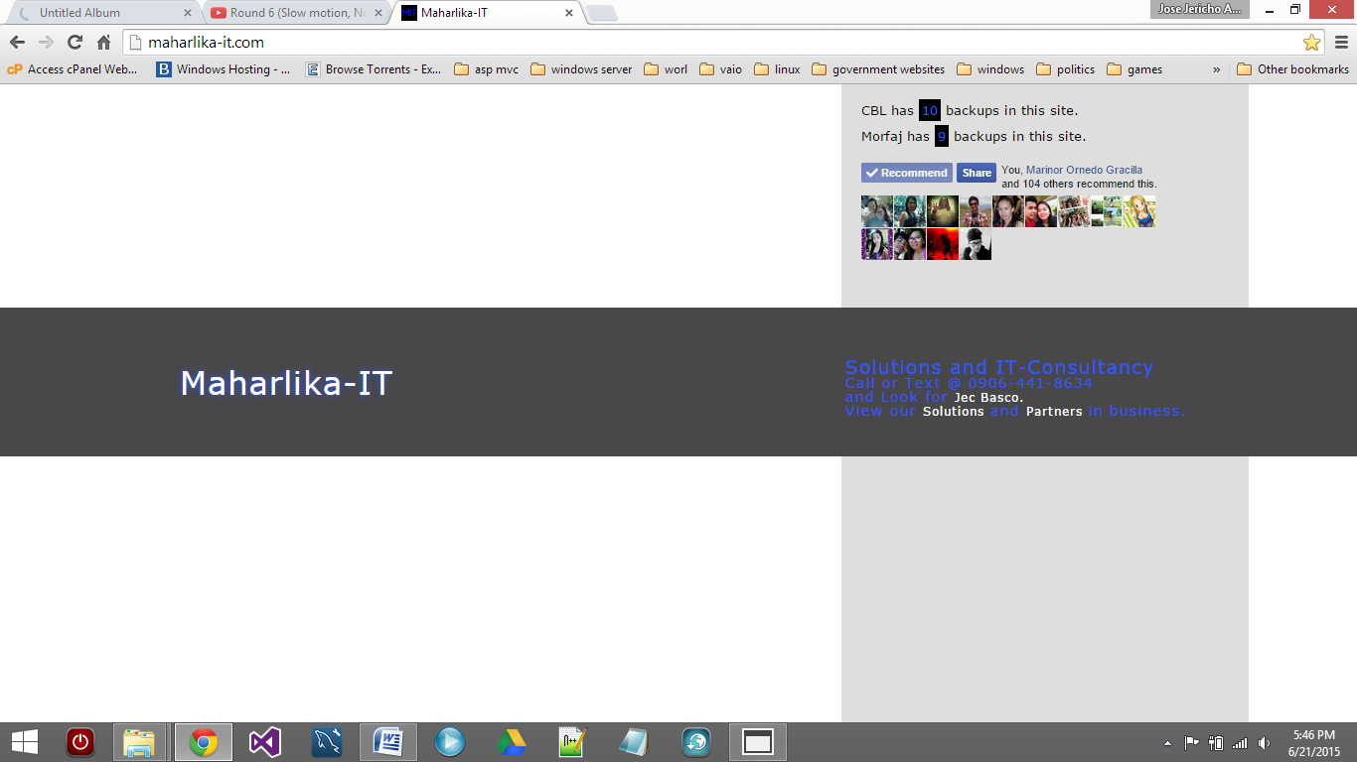

**MIT-LENDING MANUAL**

1. **Hardware Requirements**
   1. HDD Space (at Least 10gb)
   2. Memory (at least 2gb)
   3. Processor (at least dual-core 2.5Ghz)
2. **Software Requirements (Install IN-ORDER)**
   1. Windows 7 SP1, Windows 8
   2. .Net Framework 4.5
   3. MySQL Community Installer
   4. SQLSysCLRTypes
   5. ReportViewer
   6. MySQL GUI Tools R17 Win32
3. **How to Backup Database**
   1. **Open MySQL Administrator, enter** 
      1. “localhost” as Server Host
      2. “root” as username
      3. Enter the password

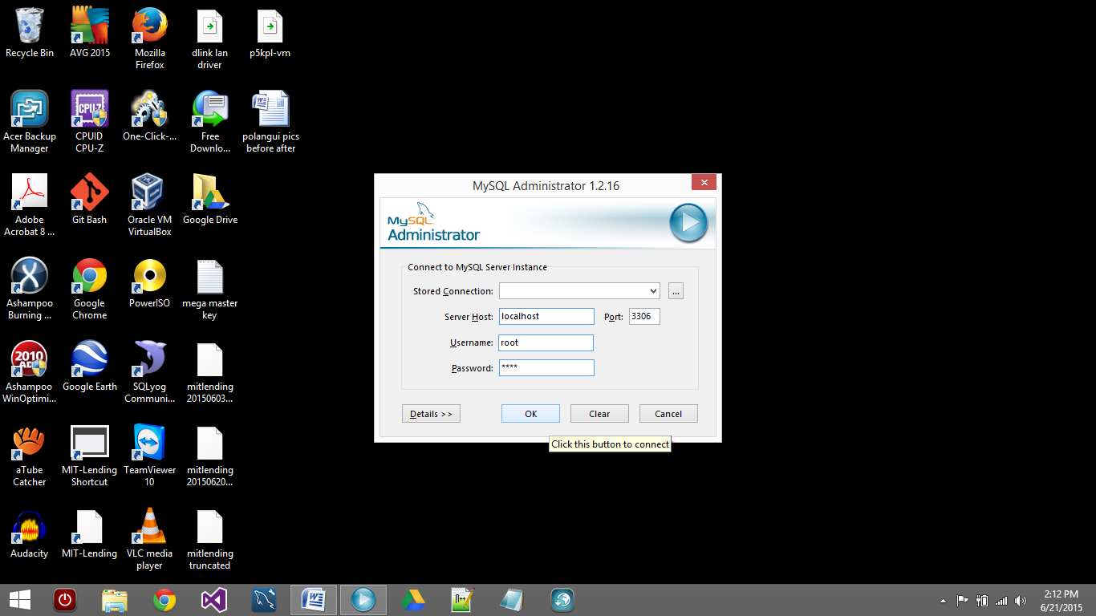

* 1. **The Main Interface**

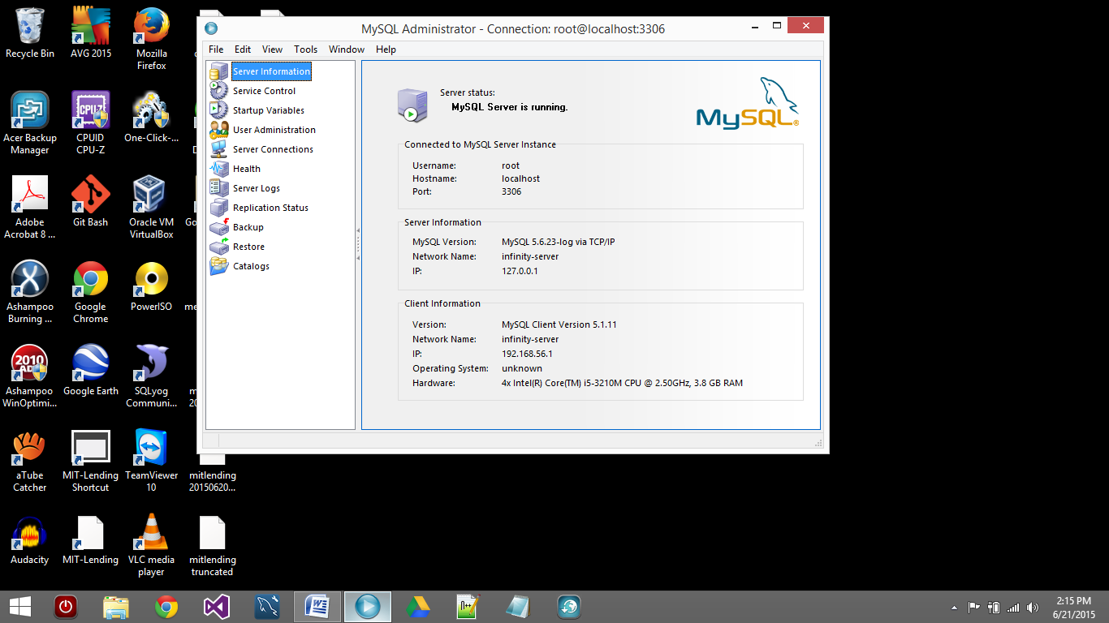

* 1. **How to backup**
     1. Click “Backup” on the left panel.
     2. Click New Project
     3. Enter backup filename

**2**

**3**

**1**

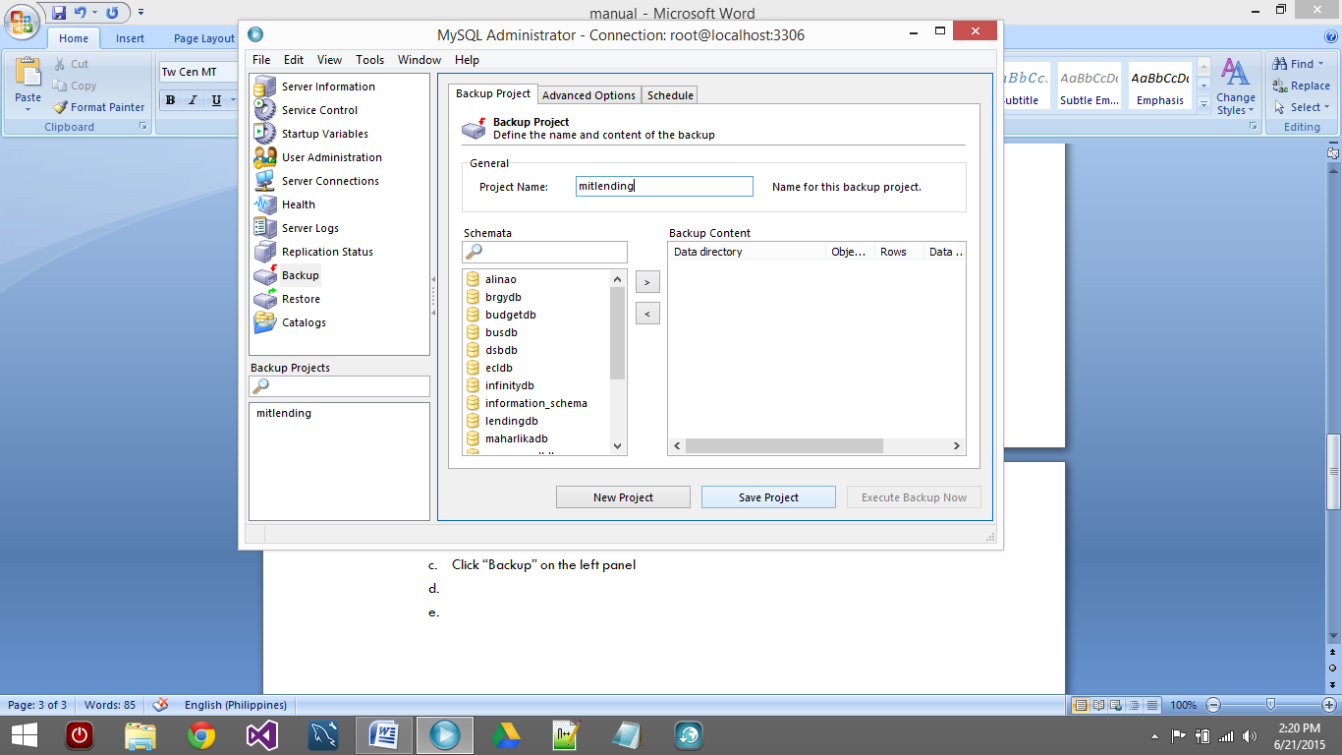

* + 1. Select lendingdb from the schemata list

**4**

* + 1. Click the “>” button
    2. The click “Save Project” 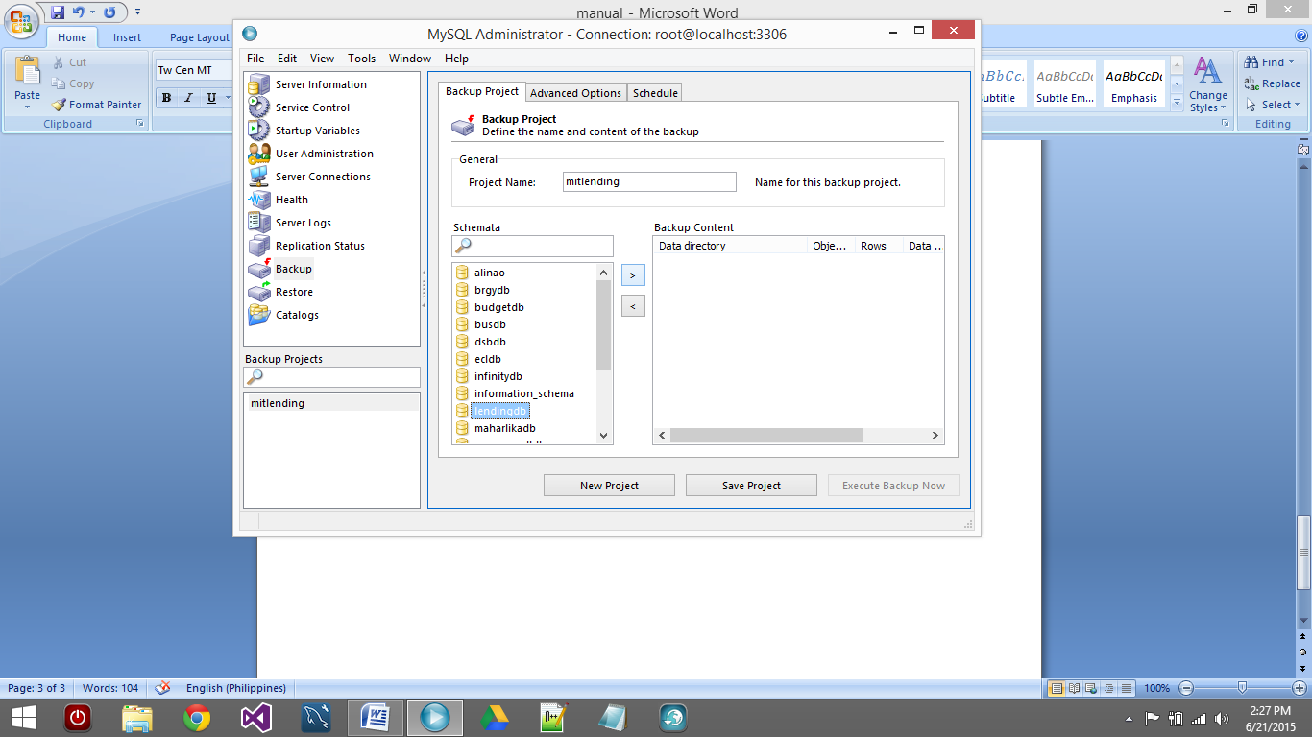

**6**

**5**

* + 1. Click “Execute Backup Now” 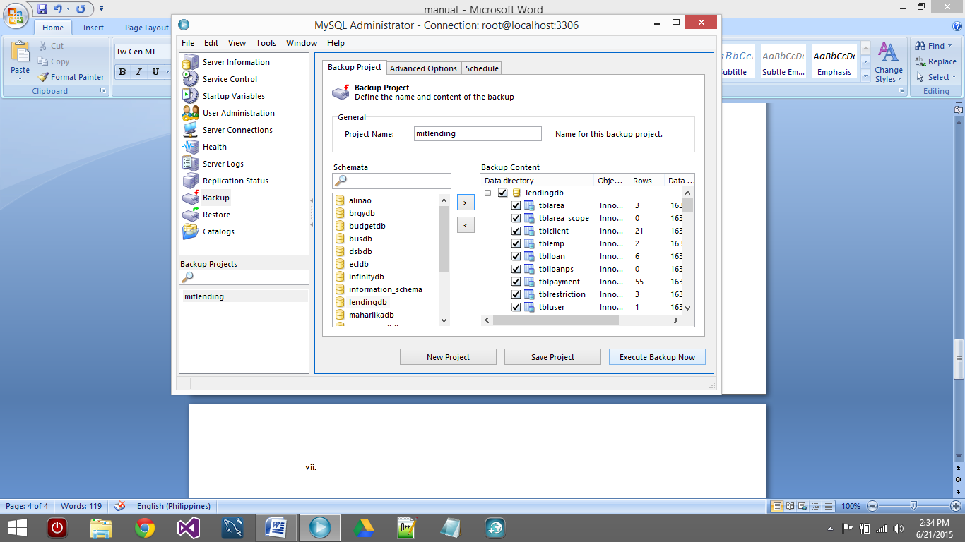

**7**

* + 1. Remember the Location of your file, then click “Save”

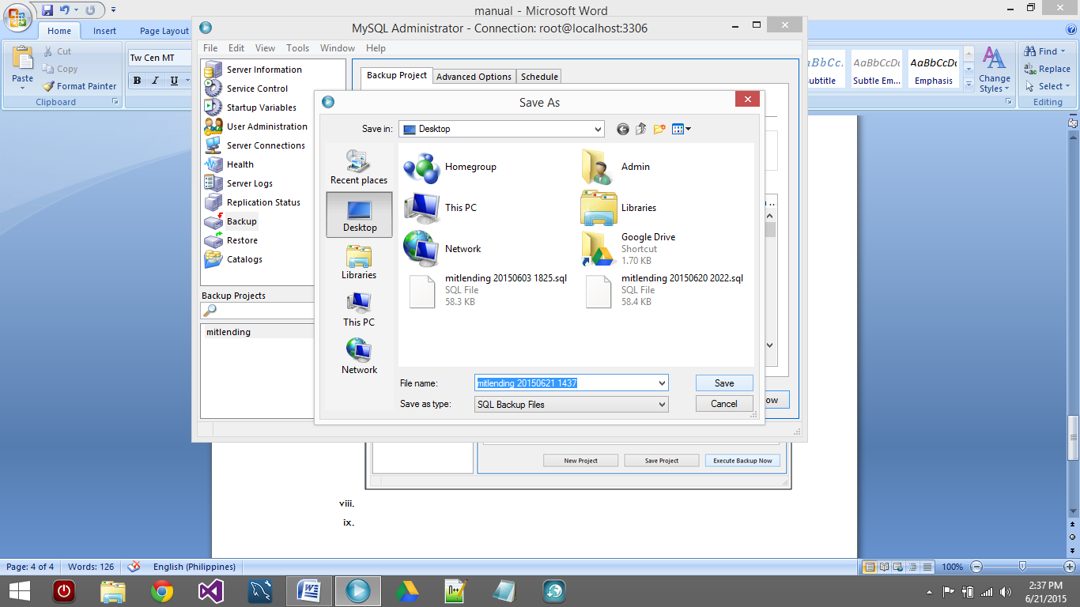

* + 1. Progress should appear after clicking save.

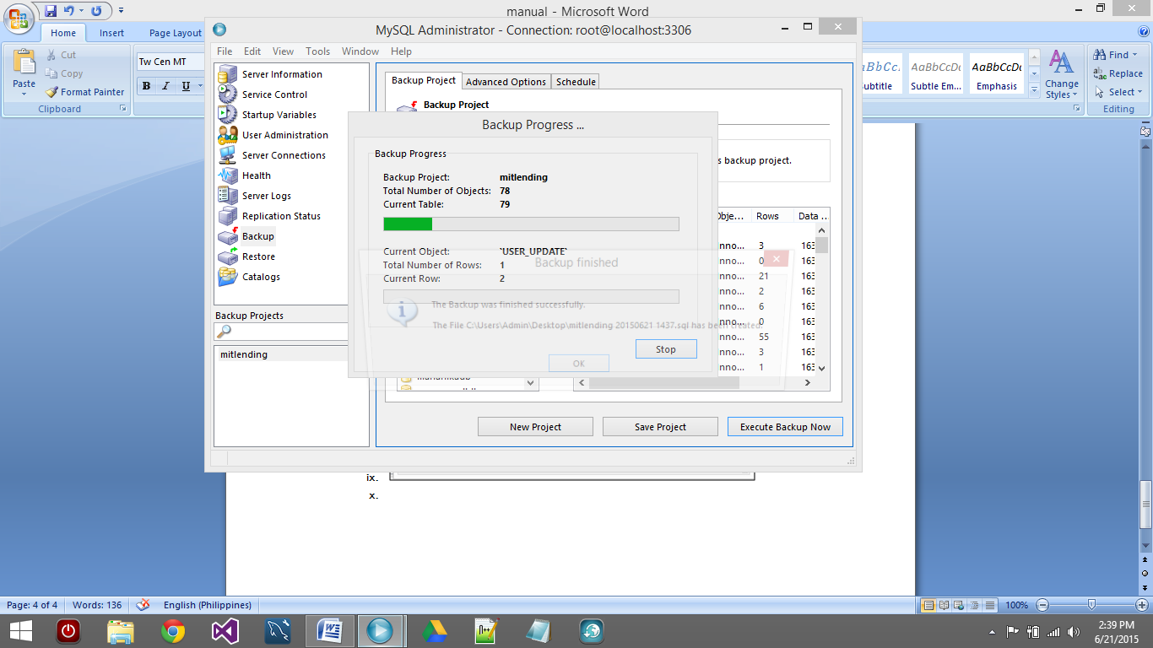

* + 1. Backup finished. 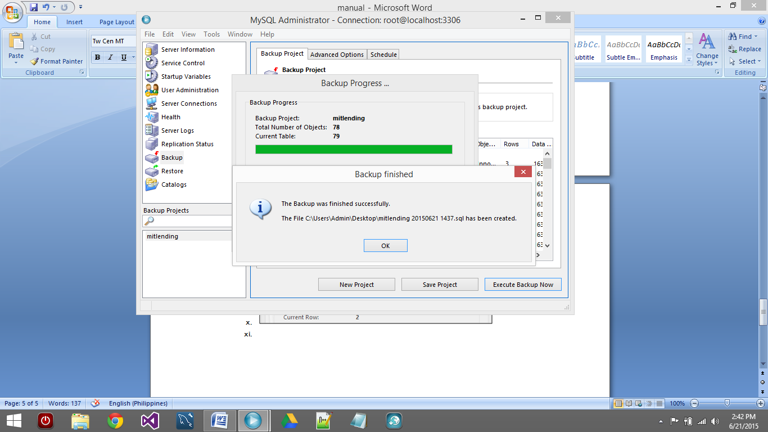

1. **How to Restore Database**
   1. Open MySQL Administrator, and enter credentials.
      1. Click “Restore” on the left panel
      2. Click “Open Backup File” 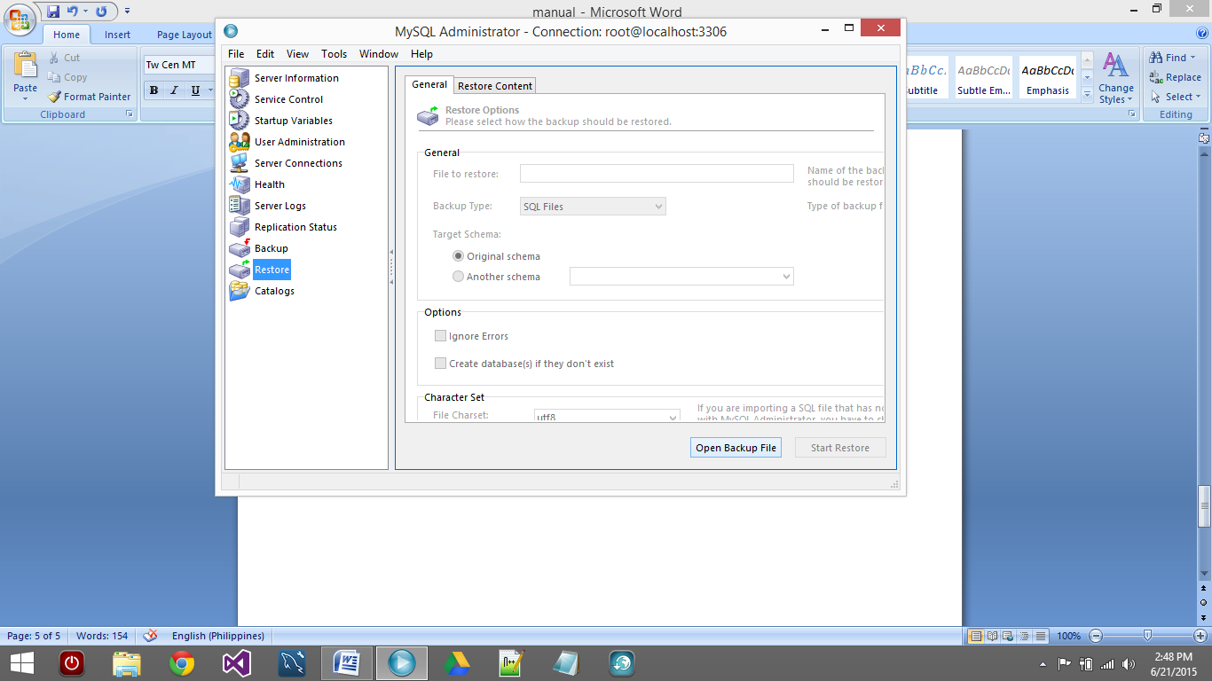

**2**

**1**

* + 1. Locate backup file. Then Click Open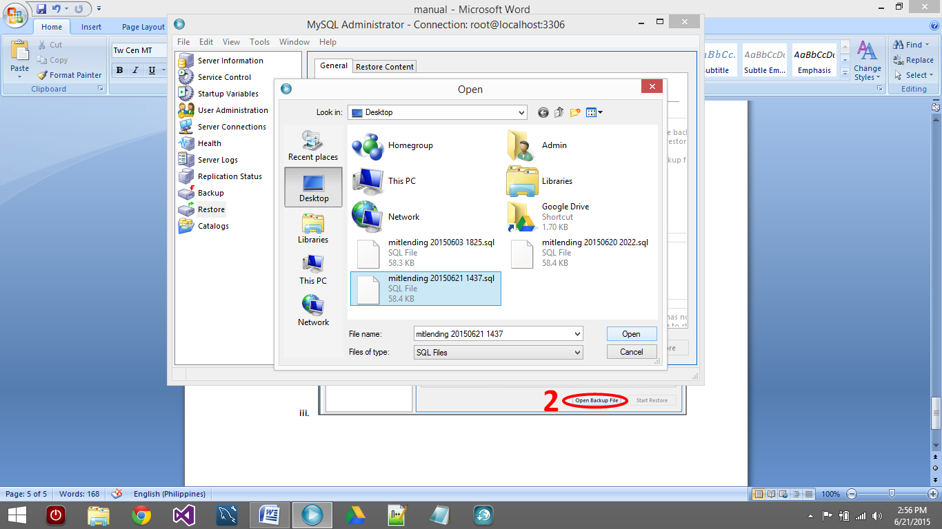

**3**

* + 1. Click “Start Restore” 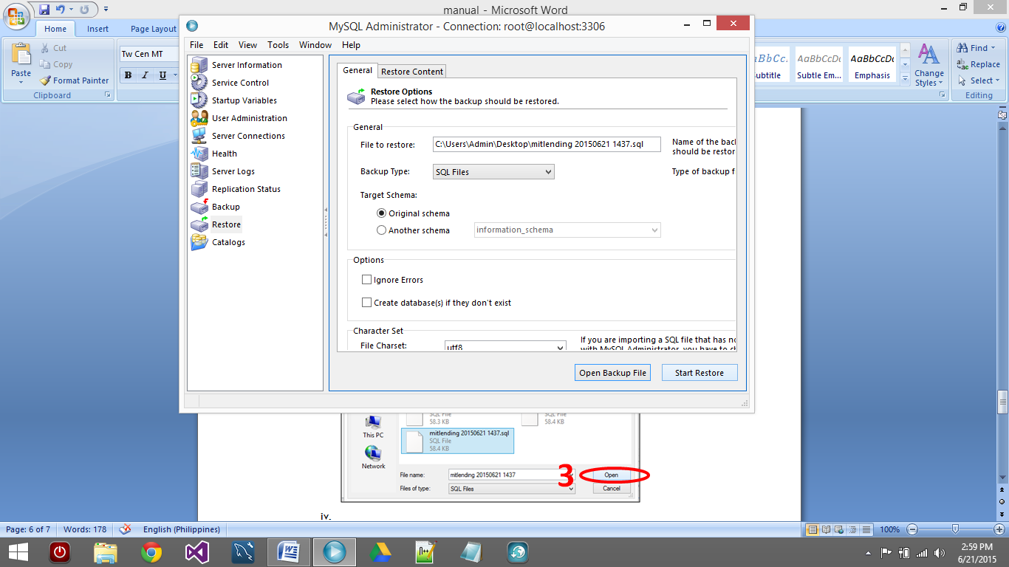

**4**

1. **Installing MySQL Community Installer**
   1. Double-click the installer.

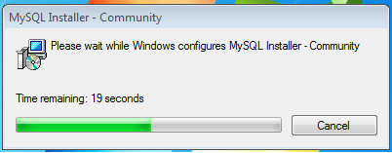

* 1. Check “I Accept Terms and Conditions”, then click next.

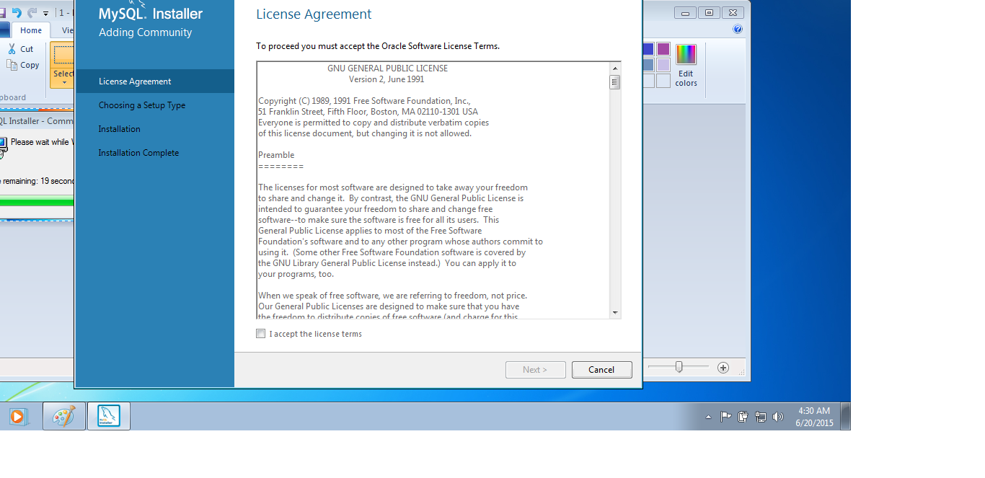

* 1. Select Custom

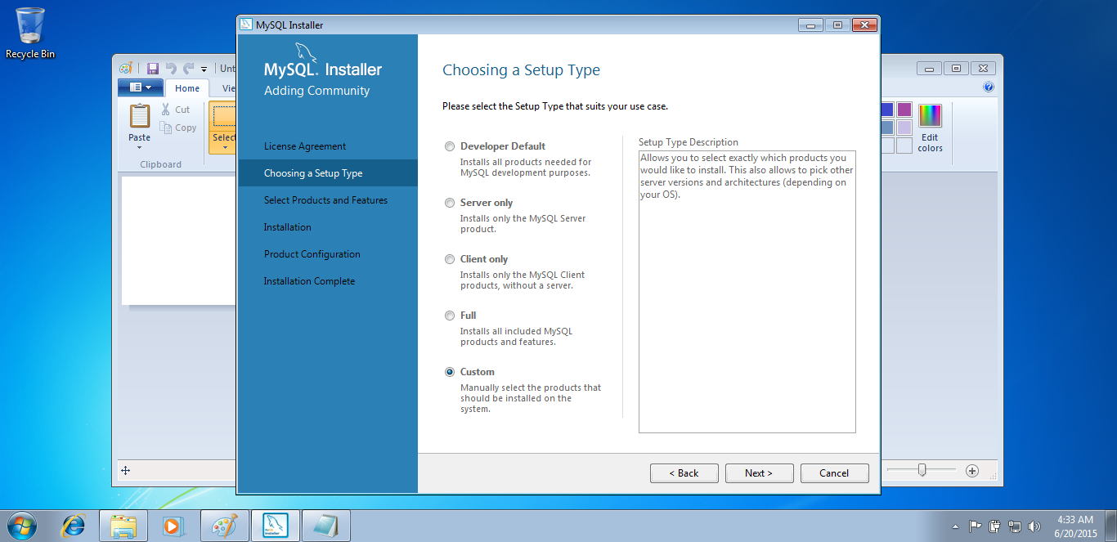

* 1. Click the “**+**” (plus) sign on the left of MySQL Servers then select MySQL Server 5.6.34- x86, then click the green right arrow to include this item in installation.

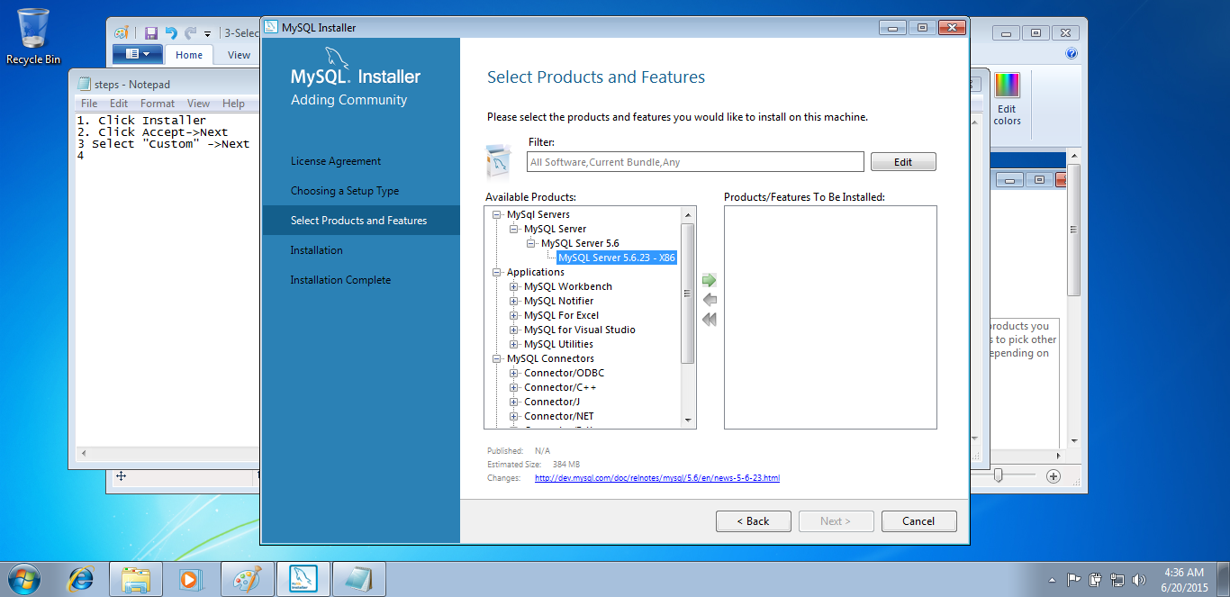

* 1. Click the “**+**” (plus) sign on the left of Applications, select MySQL Notifier, then click the green right arrow to include this item in installation.

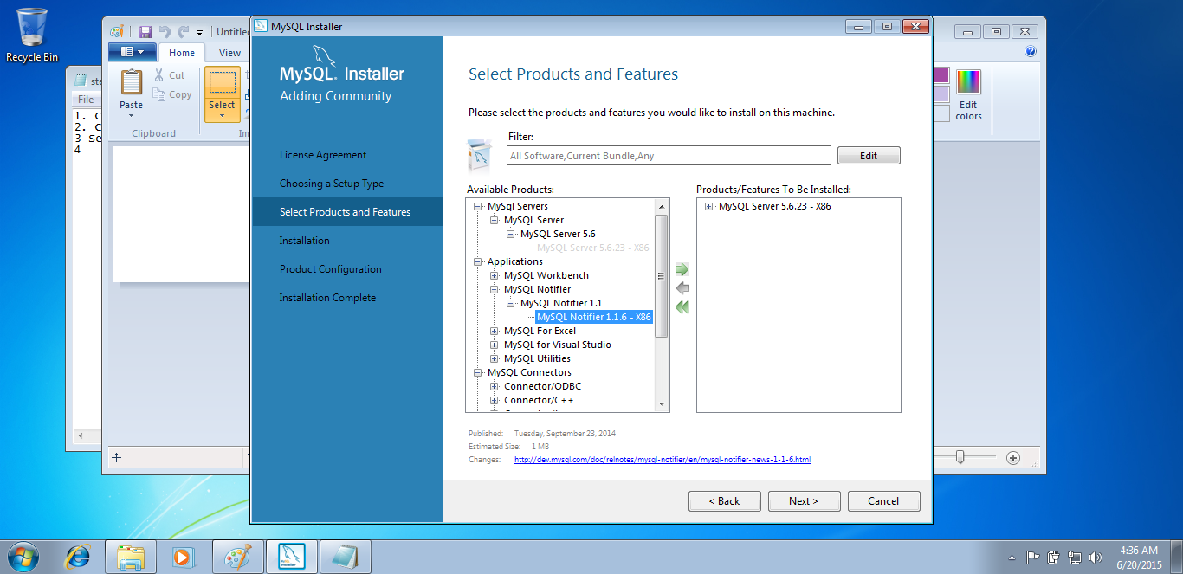

* 1. Click the “**+**” (plus) sign on the left of MySQL Connectors, select Connector/Net 6.9.5 –x86, then click the green right arrow to include this item in installation.

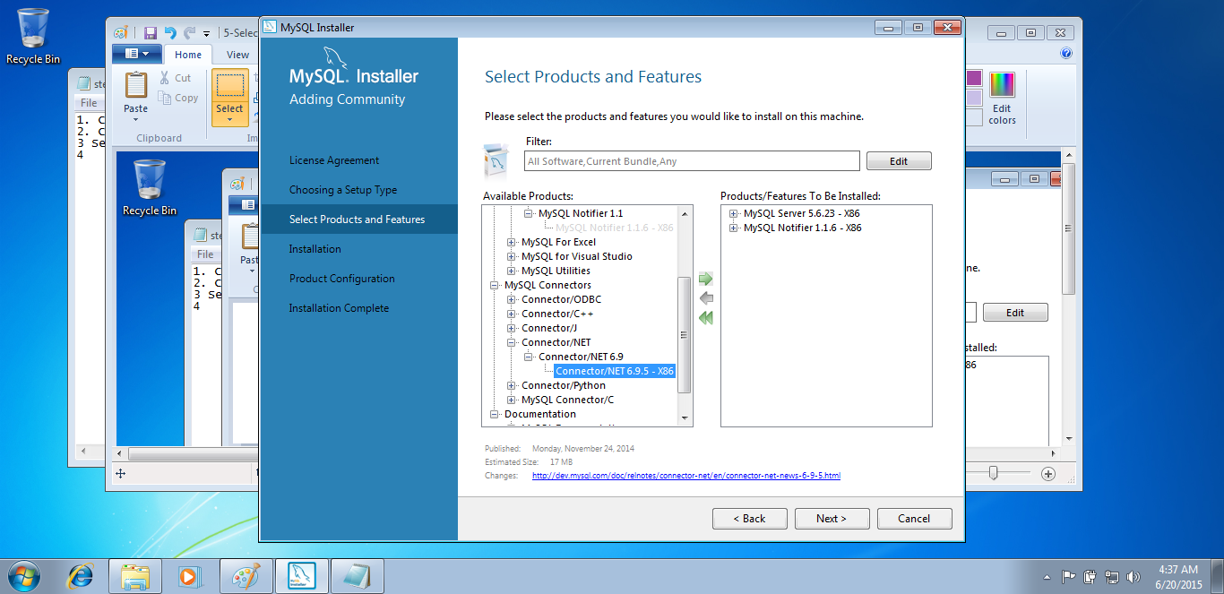

* 1. Click “Next” to proceed. Then click Execute to begin installation.

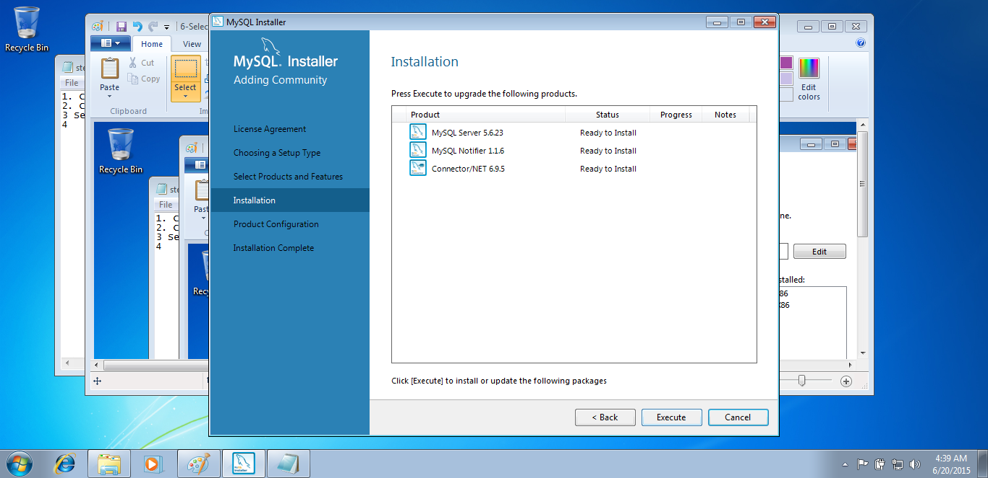

* 1. You can show details of the installation.

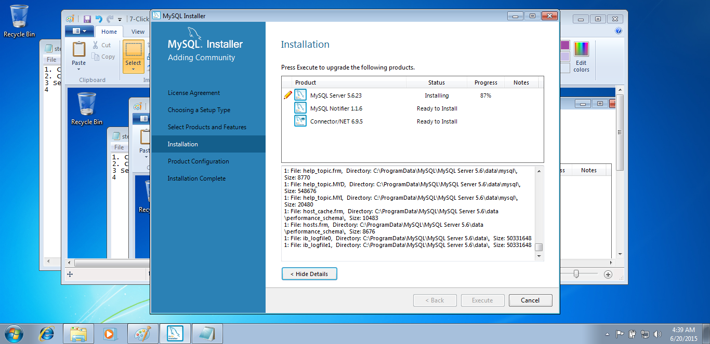

* 1. After installation completed, click next to configure the new database server.

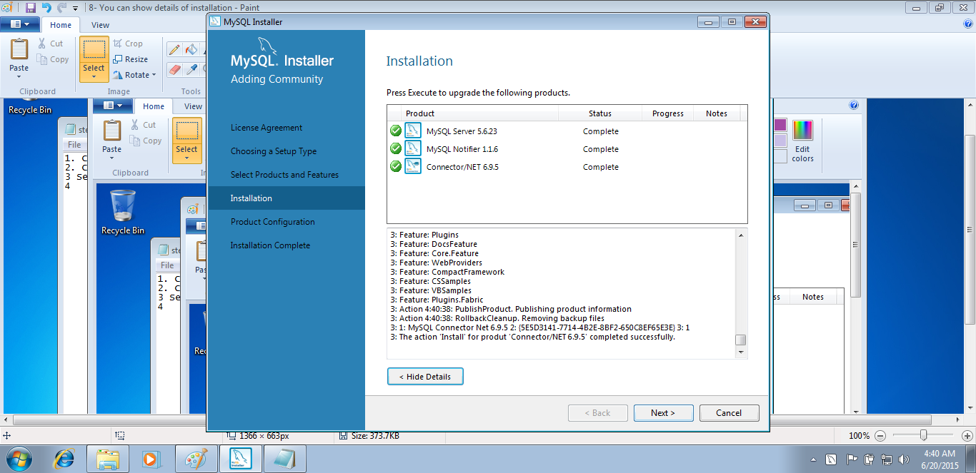

* 1. Check port number. Don’t change anything on these settings, click next to proceed.

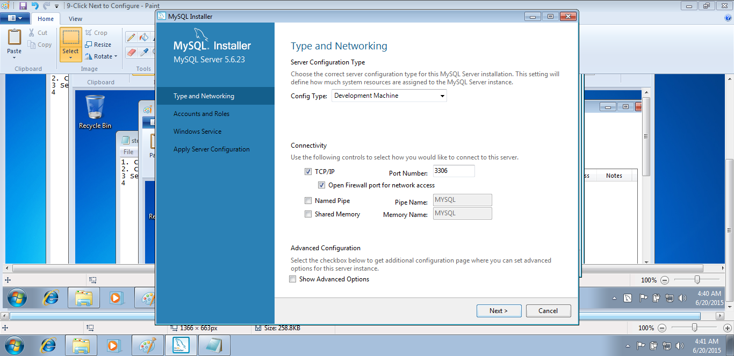

* 1. Enter “root” as password, don’t add any user. Click next to proceed.

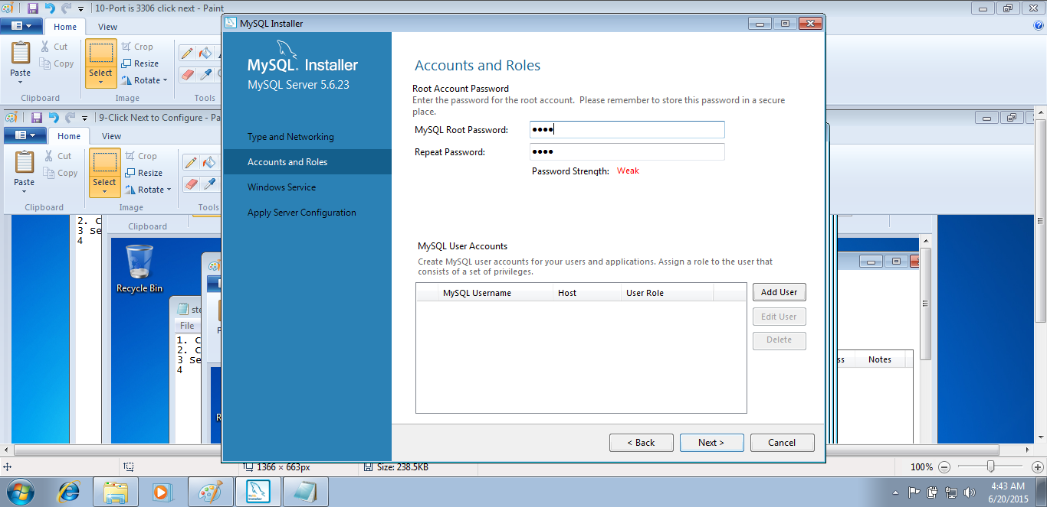

* 1. Click “Next” to start the newly configured server.

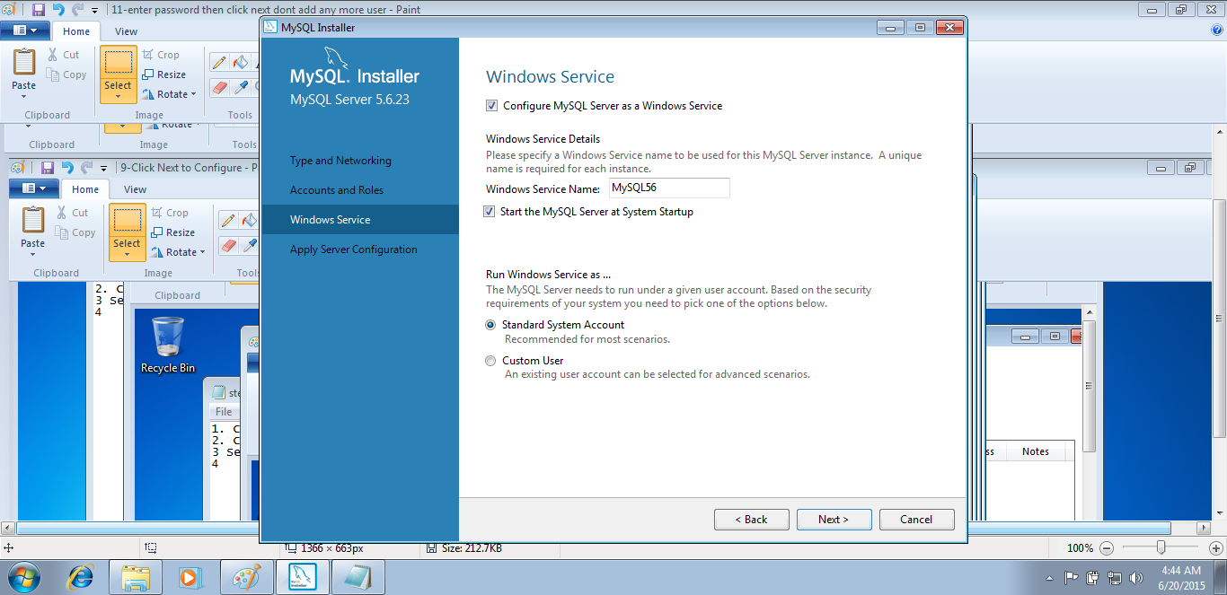

* 1. Server is starting up.

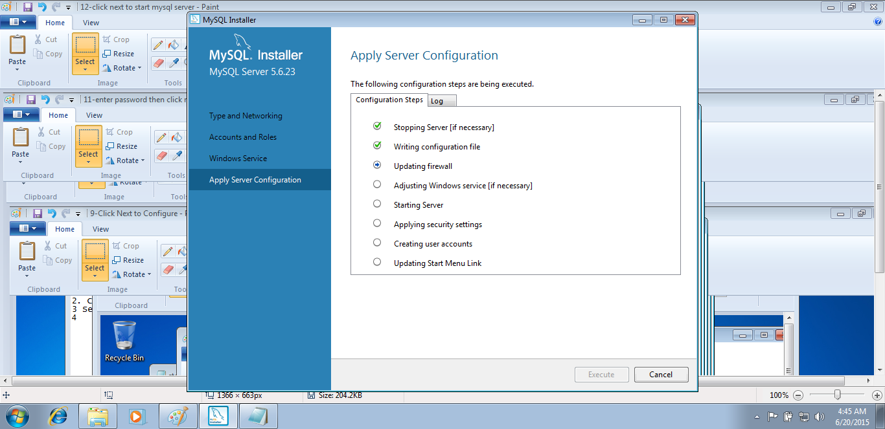

* 1. Click “Finish”

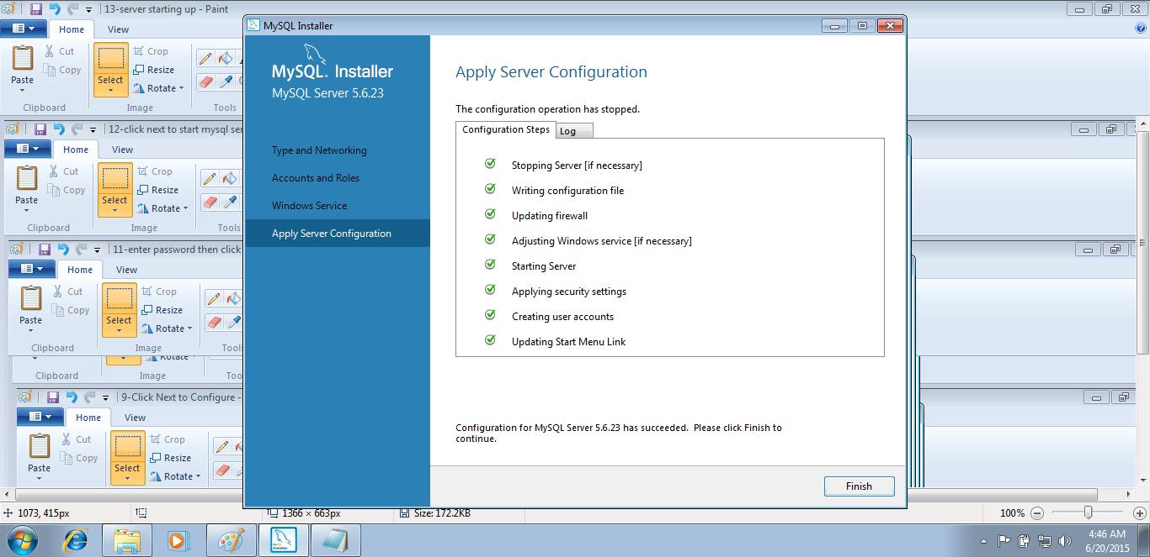

* 1. Configuration Completed

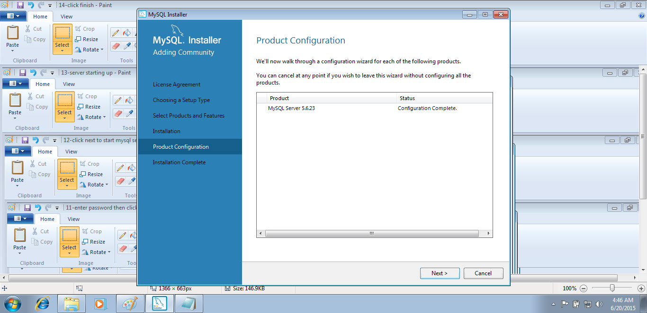

* 1. Finally Click “Finish”

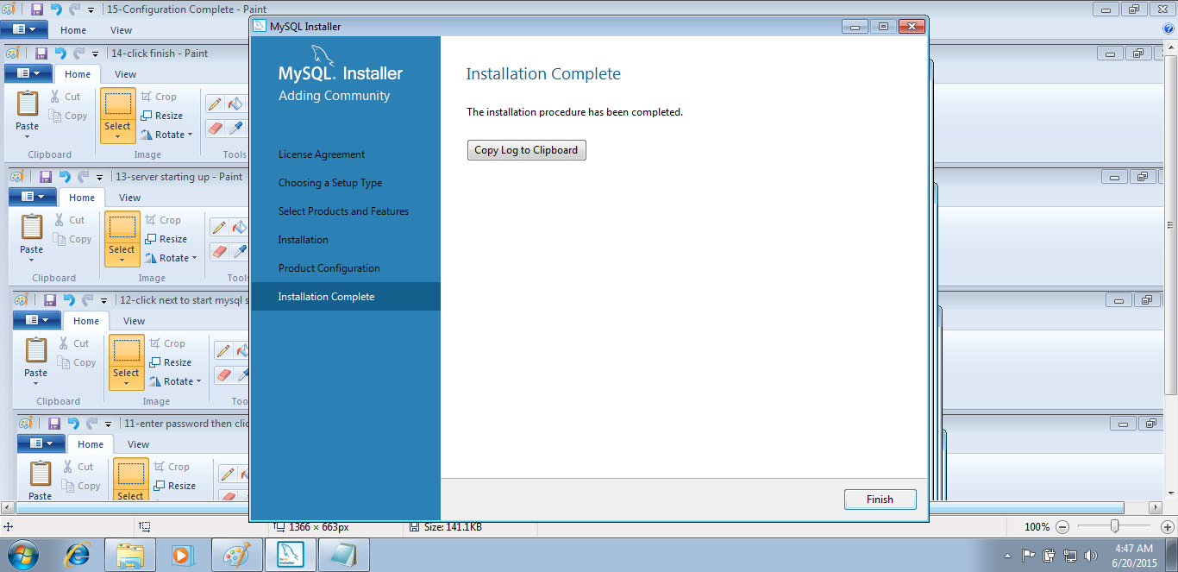

1. **Installing MySQL GUI Tolls r17.**
   1. Double-click the installer

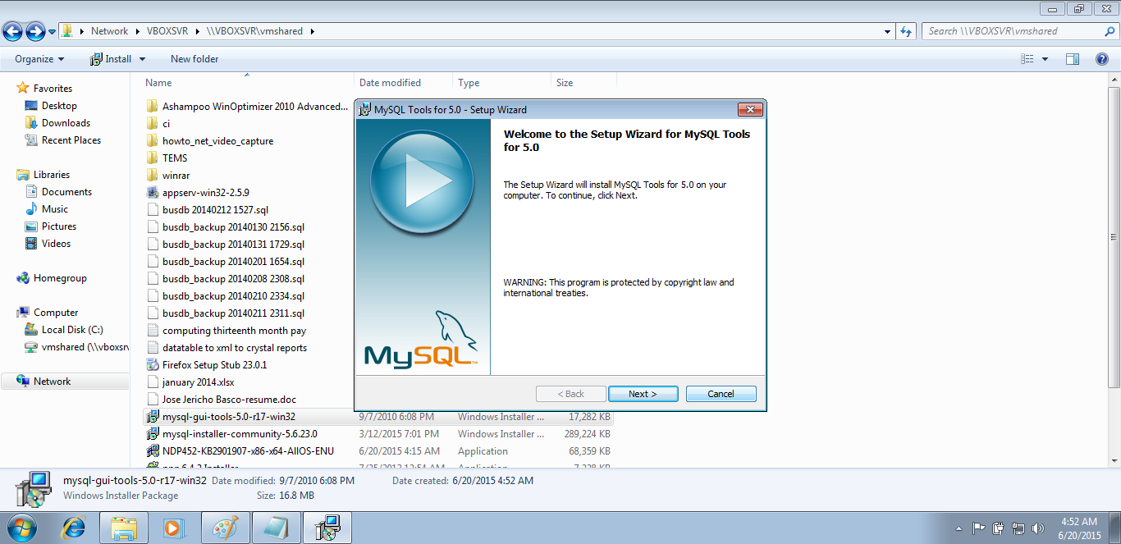

* 1. Click “Next” to proceed.

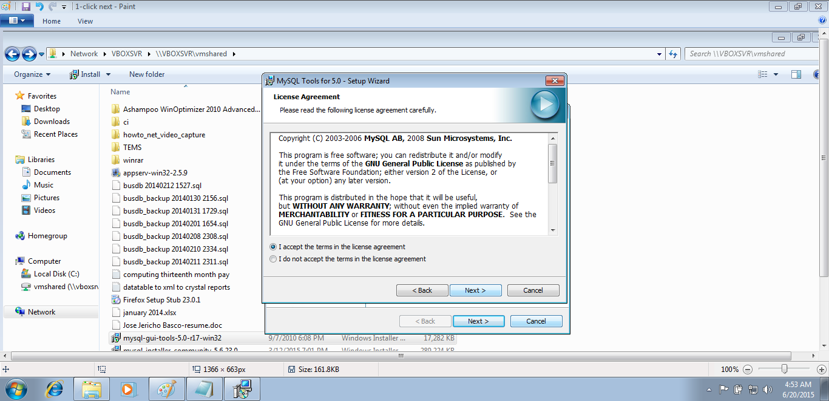

* 1. Check “I Accept the terms in the license agreement”, and then click next.
  2. Select “Complete”, and then click “Next”

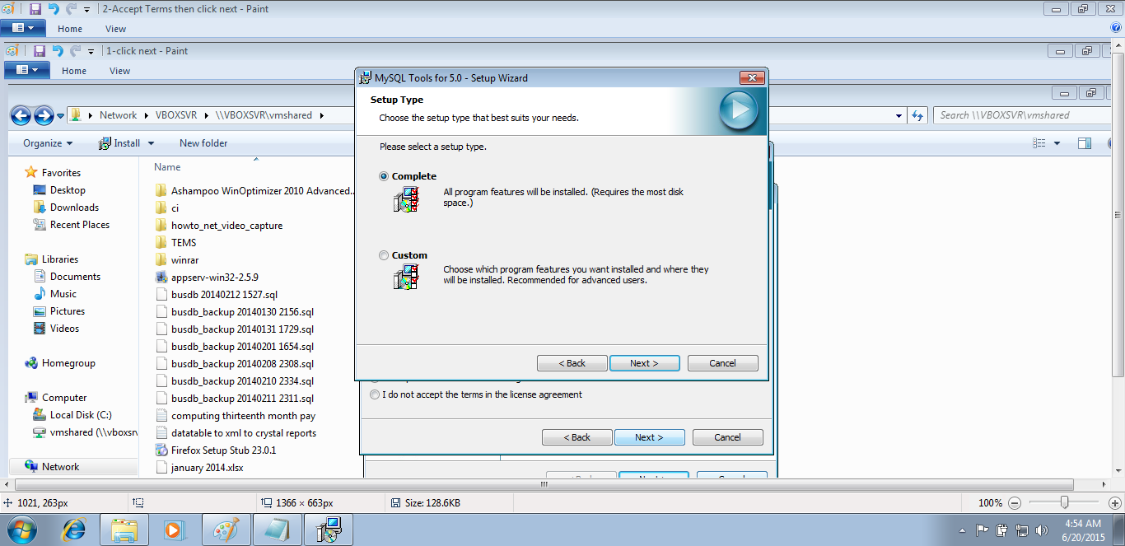

* 1. Click “Install” to proceed.

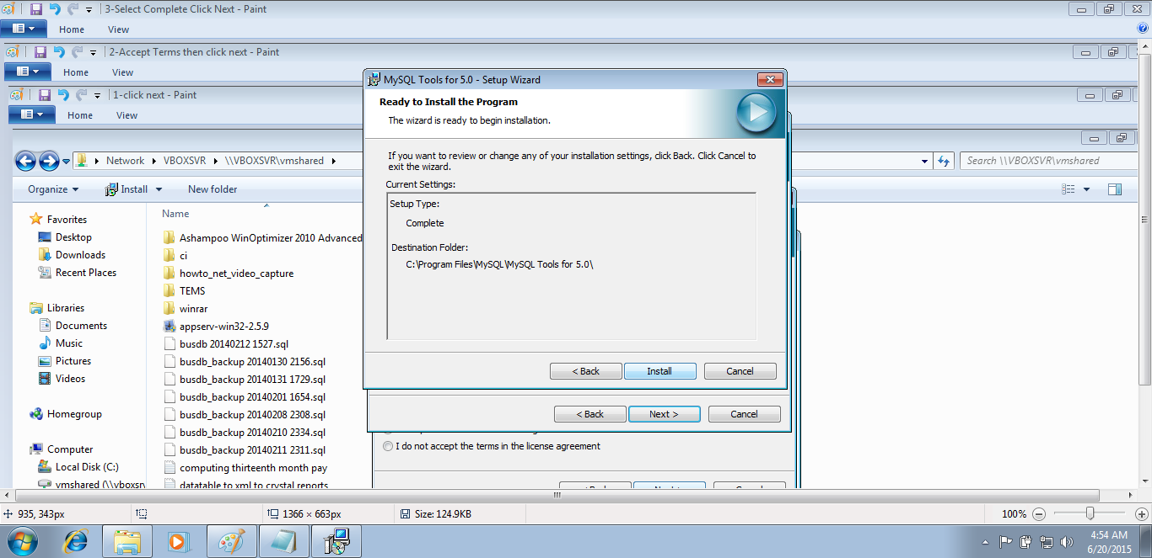

1. **How to Install MIT-Lending Application**
   1. Double-click the installer, click “Run” when security warning prompted.

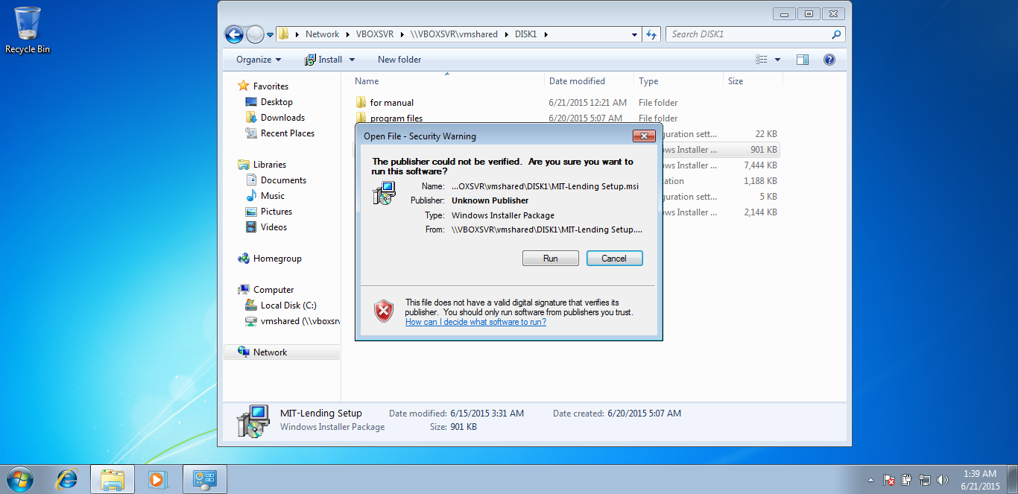

* 1. Click “Next” to proceed installation.

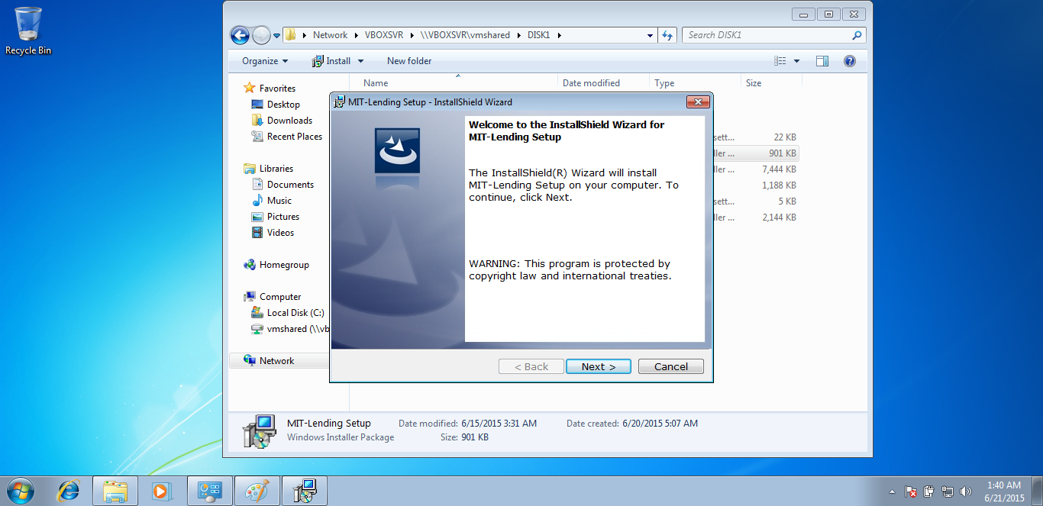

* 1. Click “Next” to proceed.

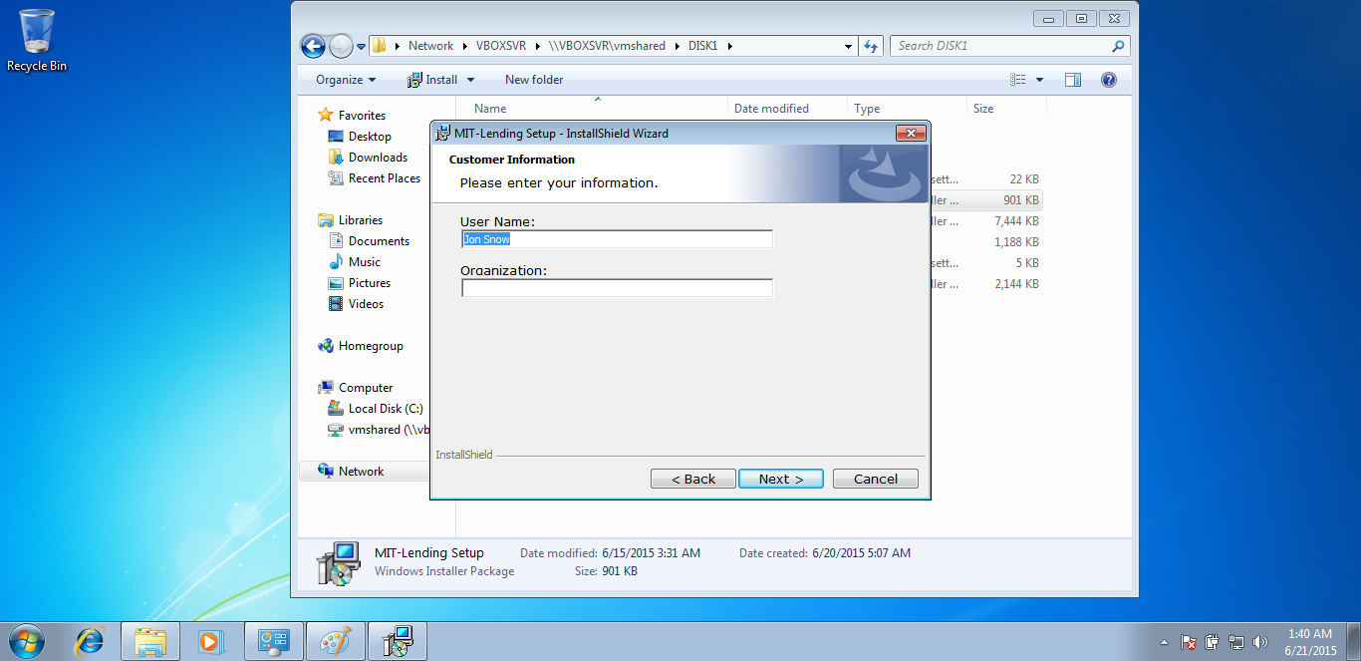

* 1. Click “Install” to proceed.

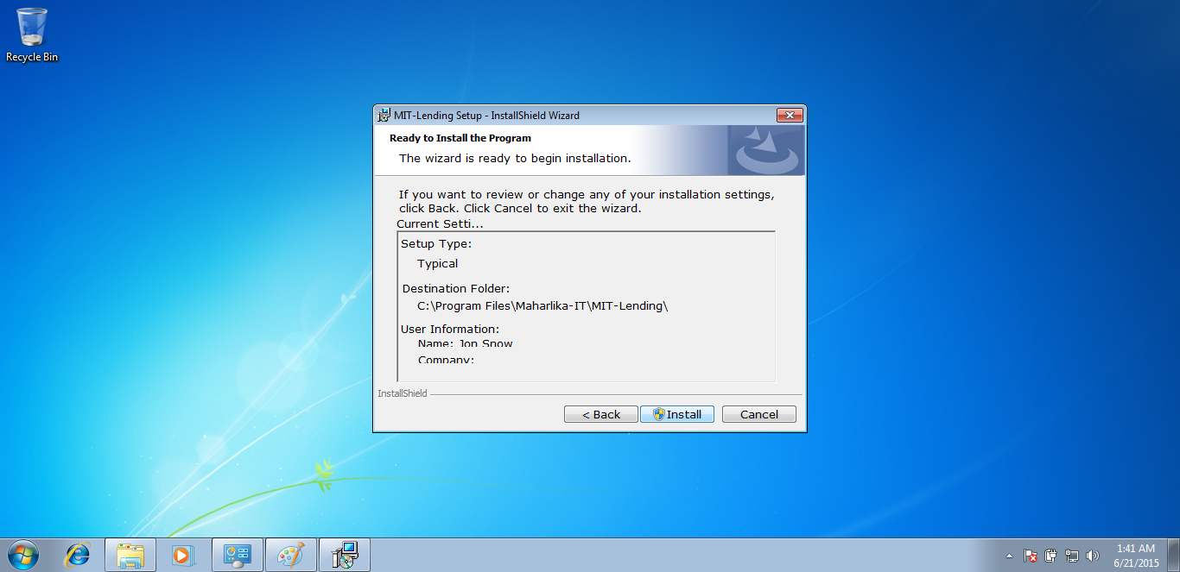

* 1. Allow user to install this software.

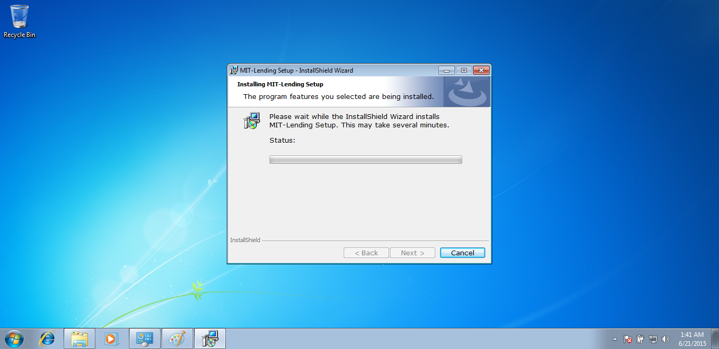

* 1. Finally, click finish. “MIT-Lending Shortcut” should be available in the desktop after this.

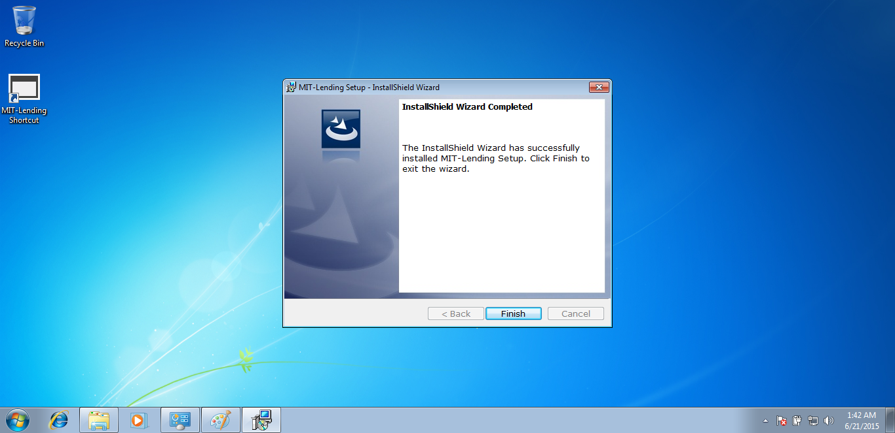

1. **How to Use MIT-Lending Application**

*Note:*

*Every button available on this application is controlled by a user restriction, so if you don’t find the button in the instruction, you might have no access to that module.*

*Main Modules:*

* *Payments*
* *Loans*
* *Clients*
* *Employees*
* *Reports*

*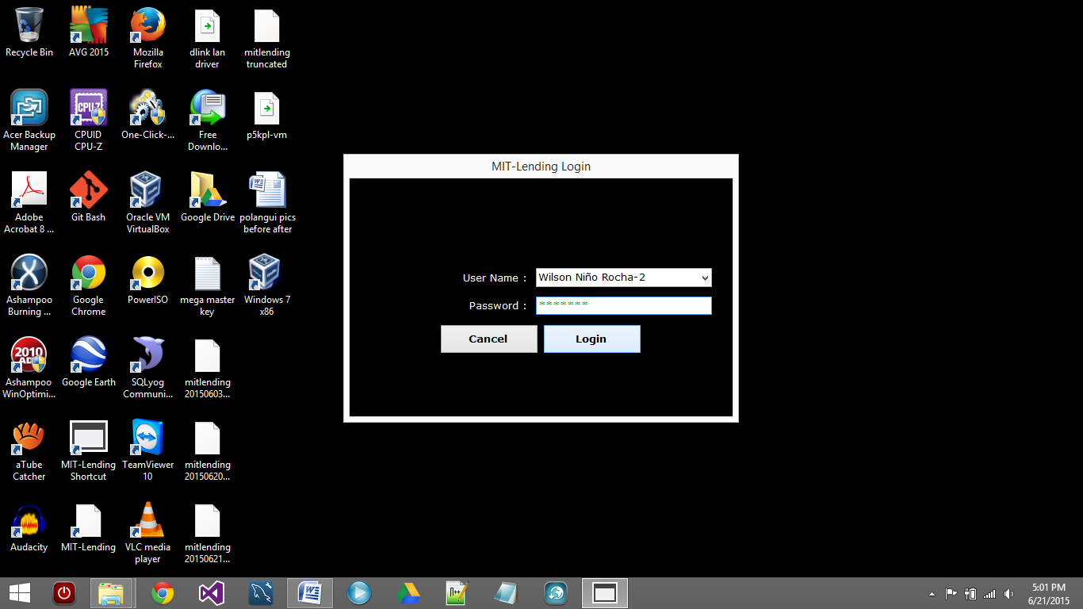 Login Interface*

*Note:*

*Once you’re logged-in you will see the following window.*

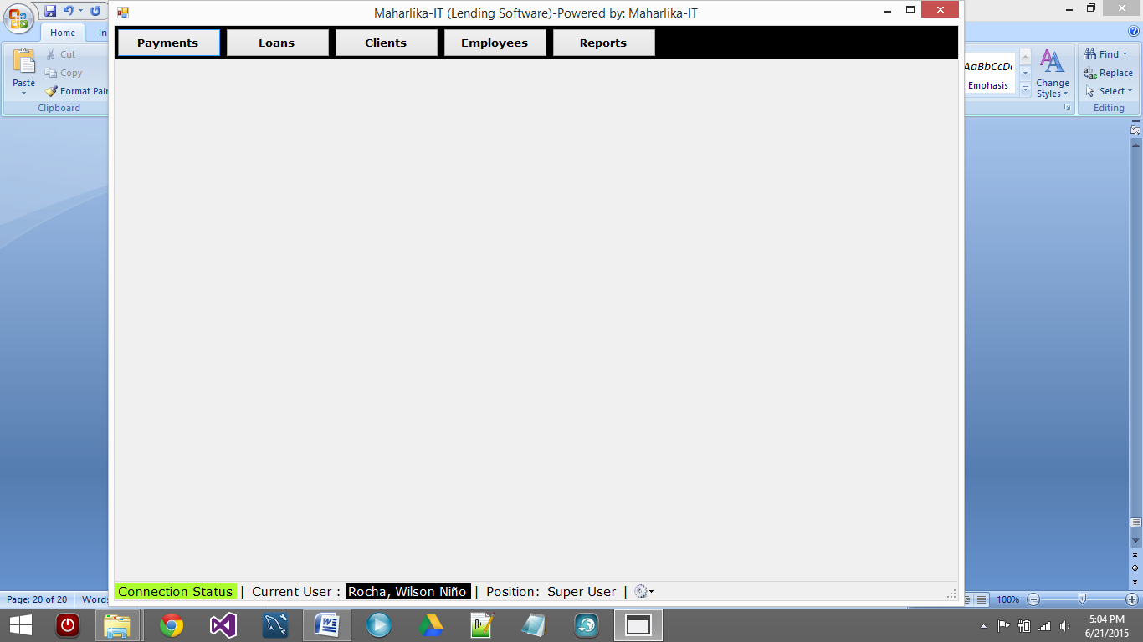

*Note:*

*The data below the main interface indicates the connection status: GREEN, means connected,*

*RED, means network error. The current user and his/her position is next to the connection status. You can also access settings from this area of the user interface.*

*All modules have pretty much the same interface, adding, deleting, searching, editing and updating.*

*So, for example we will tackle the employee module.*

* 1. **EMPLOYEES**
     1. Click “Employees” button



* + 1. To **ADD_NEW_EMPLOYEE** click “New”

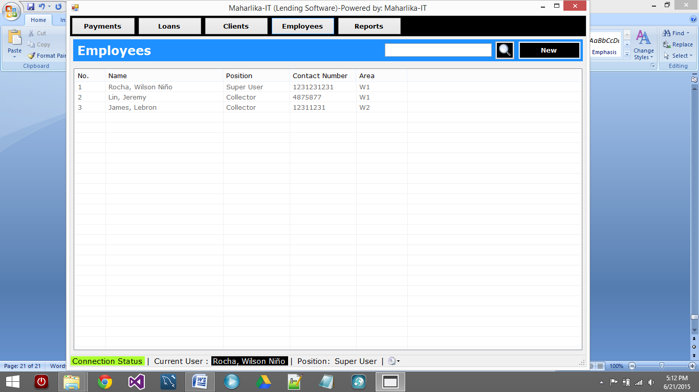

* + 1. Fill-in the required fields, then click “Save”. Note: you can’t proceed if one item is not filled. 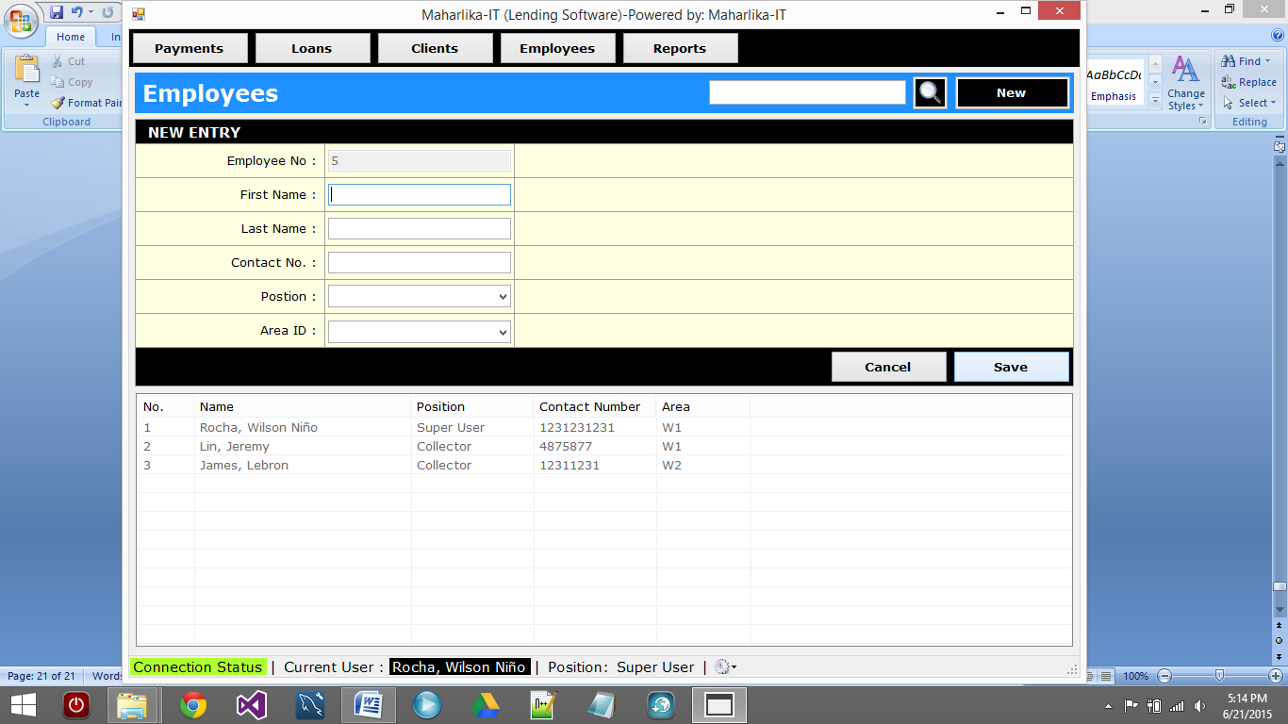
    2. A message box will appear prompting the status of the action, success or failed, if failed read the error, print the screen if possible and then contact developer.

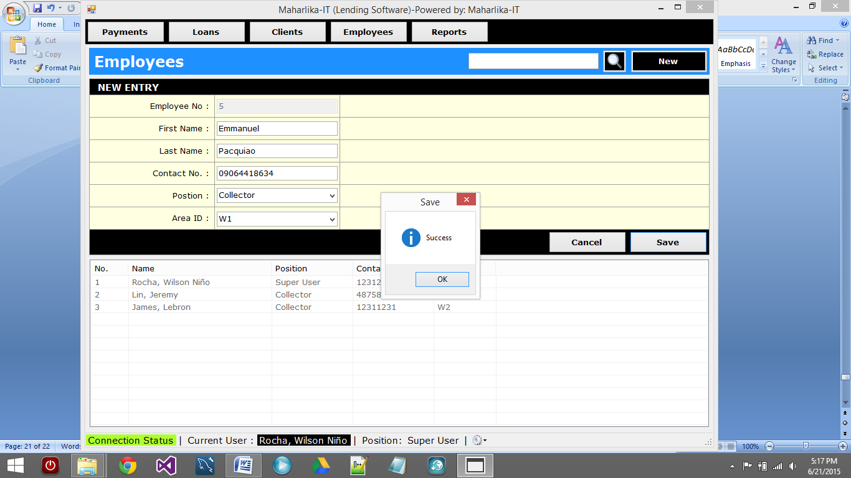

*Note: a newly created employee has a default password of: “****mitpass****”*

* + 1. To **EDIT_EMPLOYEE** you will need right-click the employee you need to edit with, and then click edit.

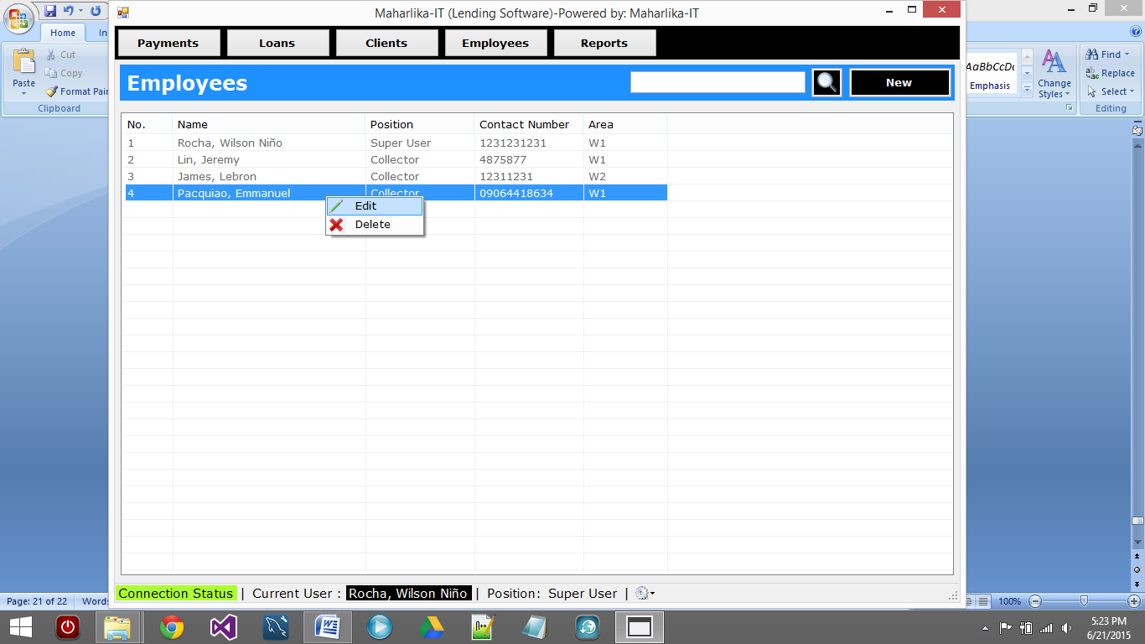

* + 1. Change incorrect data, then click “Update”

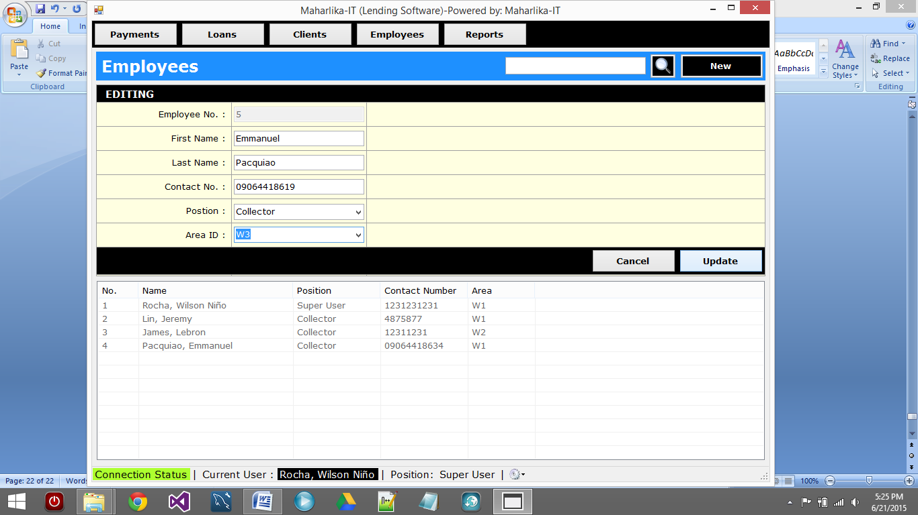

* + 1. To **DELETE_EMPLOYEE** you will need right-click the employee you need to edit with, and then click delete.

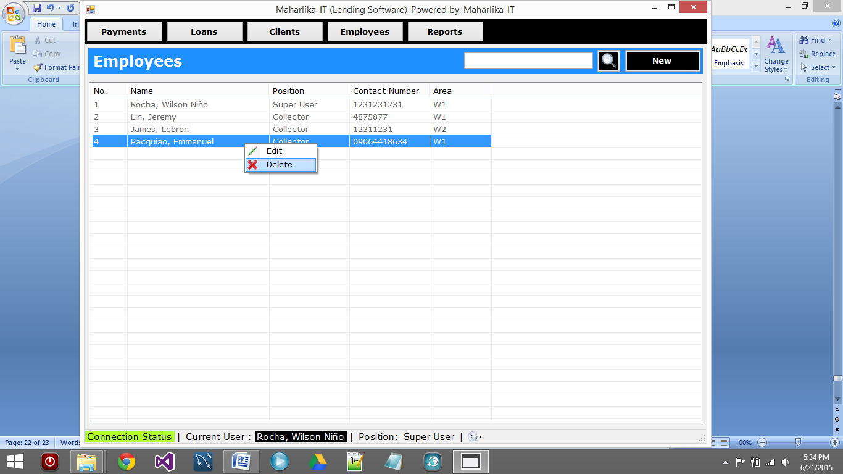

* + 1. Click “Yes” to Confirm Delete

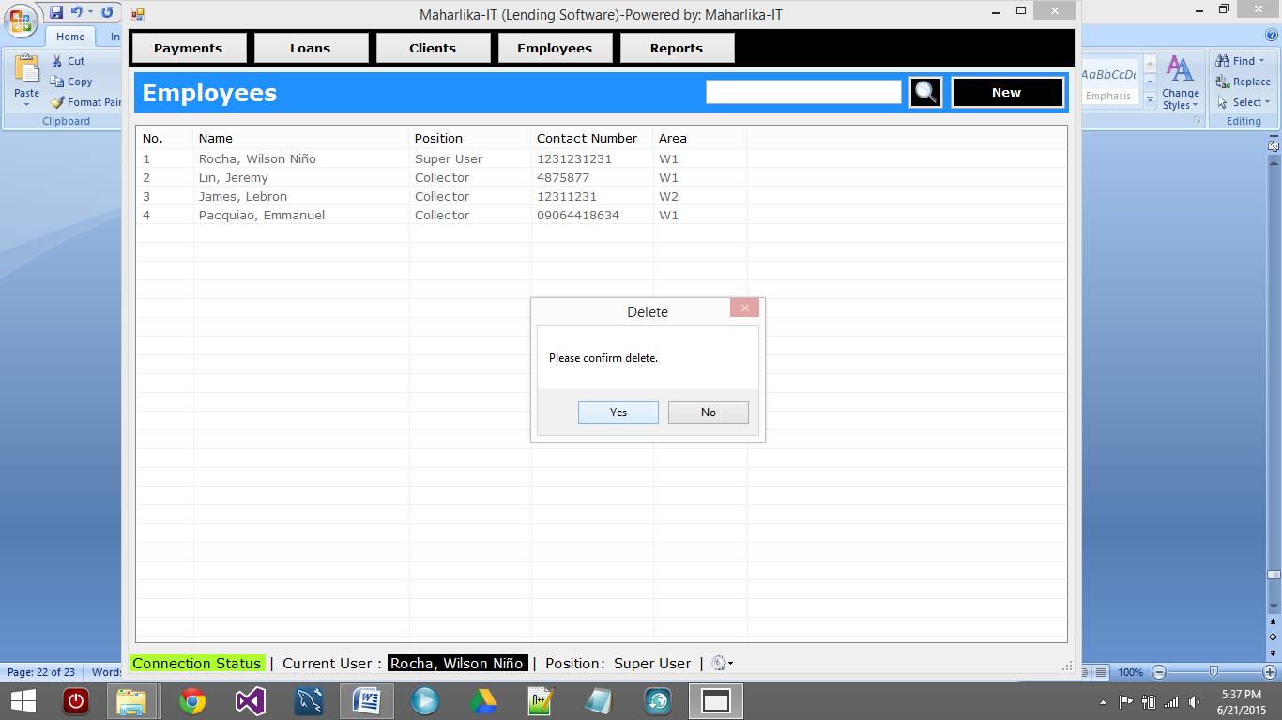

* + 1. A message box will prompt indicating the status of the action, success or failed.

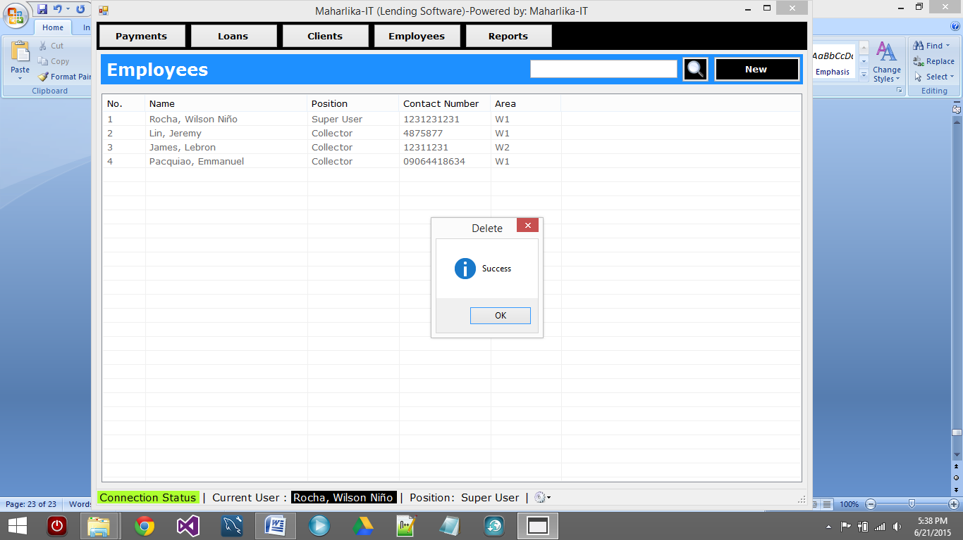

* 1. **PAYMENT**
     1. Click “Payments”



* + 1. The list of payments made is listed shown.

*Note: Payment is generated according to CUTOFF, so you have to select the MONTH, the CUTOFF range, and the AREA and then click “Generate”.*

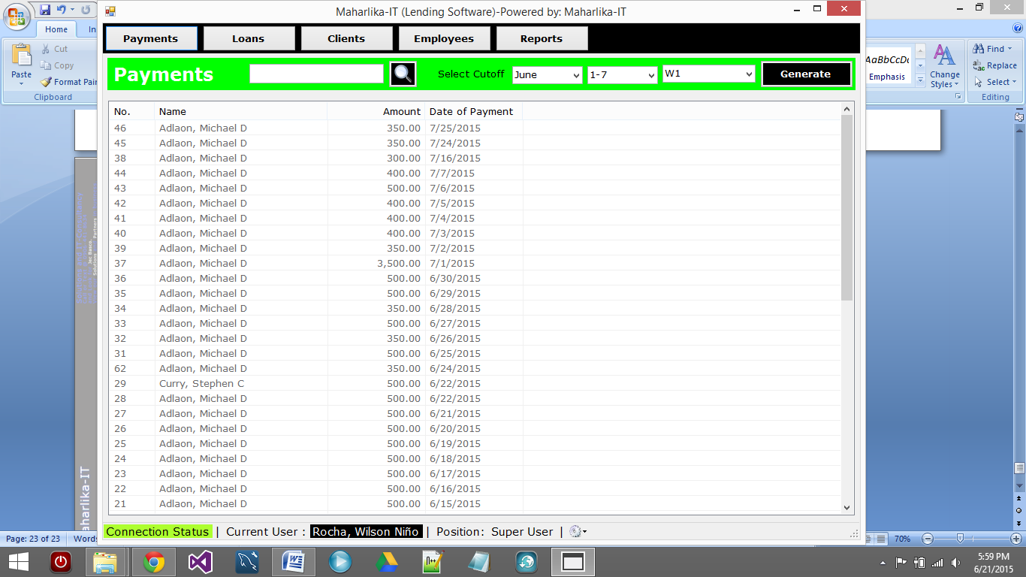

* + 1. A week of payment entry is generated for the selected month, cutoff and area combination. Only clients with active loans are listed in this generated payment entry.

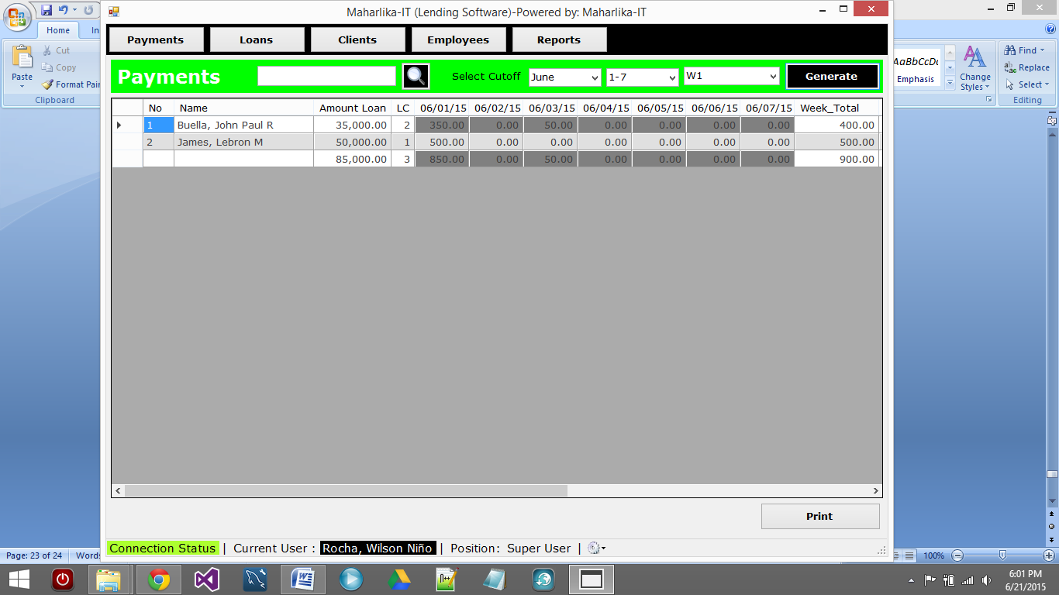

* 1. **SETTINGS and RESTRICTIONS**

Note: This can be found at the bottom of the main user interface.

* + 1. Click the gear icon at the bottom then click settings.

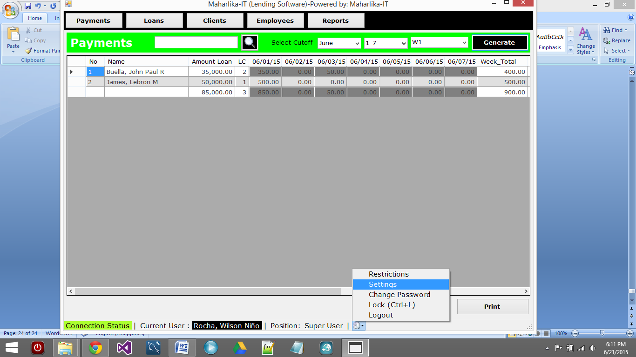

* + 1. Here you can:
       1. change the Company Name
       2. change the Owner
       3. modify area settings
       4. enable /disable formatting

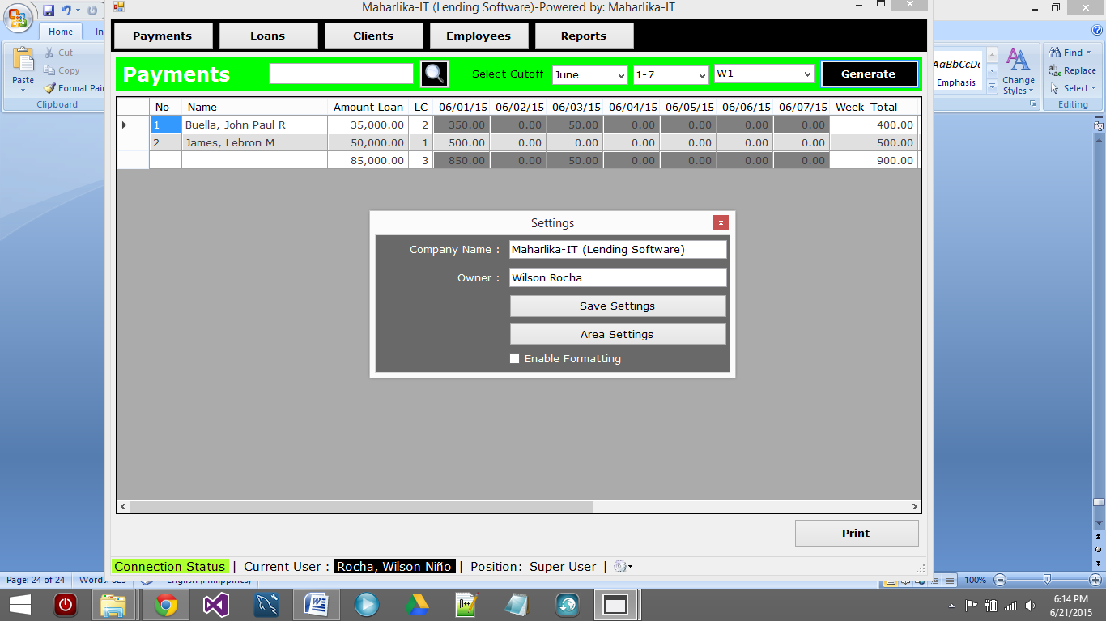

* + 1. The following is the window for changing restrictions.

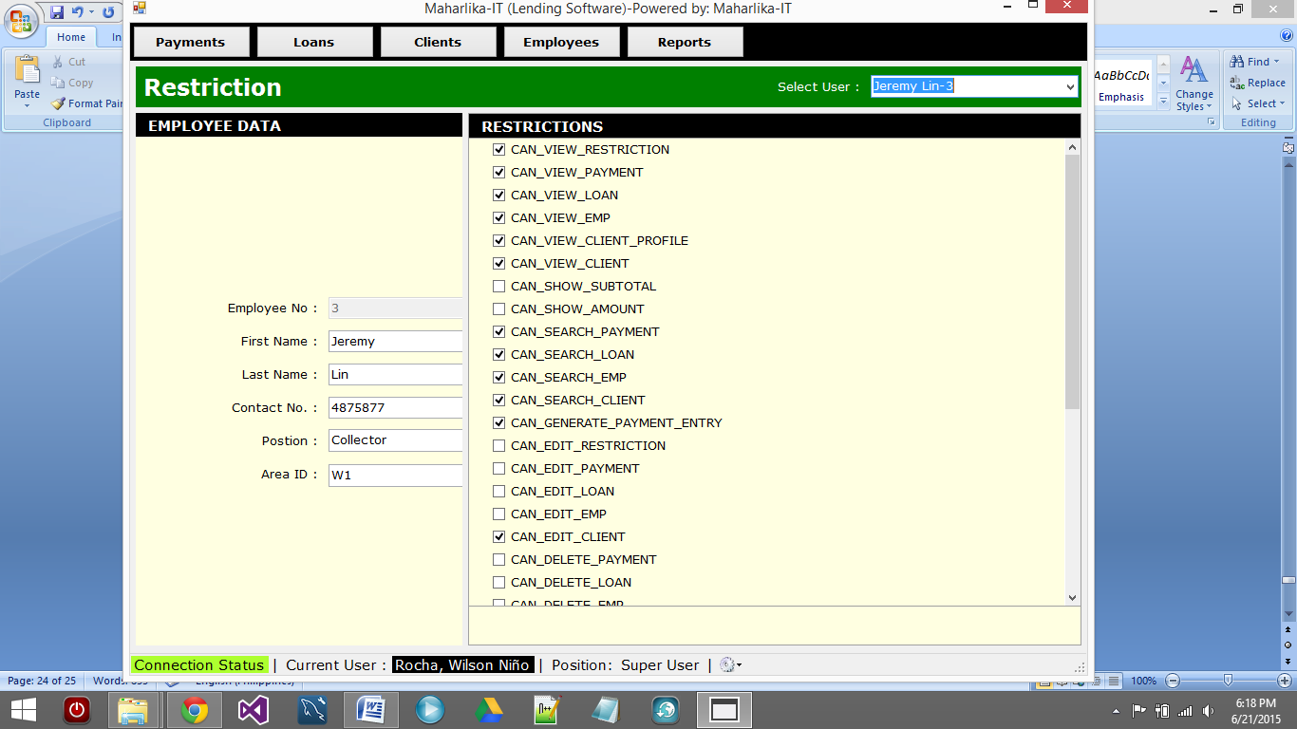

* + 1. You can just check or uncheck certain restriction for a user.